**DBMS STUDENT PROJECT REPORT**

**ACADEMIC YEAR 2023-24**

**Project Title:**

| MasterChef Globe 2024 |
| --- |

**Students:**

| **Sr. No.** | **Student Name** | **Enrolment No** | **Sem / Course** |
| --- | --- | --- | --- |
| 1 | Shaily Antala | 20220701037 | 3rd Sem Bsc-Data Science |
| 2 |  |  |  |

**GitHub Project Link:**

| https://github.com/Shaily0203/SQL-Game----MasterChef-Globe |
| --- |

**Faculty: Jatin Ambasana Dean: Dr. Raju Shanmugam**

**UNITEDWORLD SCHOOL OF COMPUTATIONAL INTELLIGENCE**

**KARNAVATI UNIVERSITY**

**INDEX**

| **Sr. No.** | **Title** | **Page No.** |
| --- | --- | --- |
| 1 | Introduction | 3 |
| 2 | Database Design | 4-5 |
|  | * ER Diagram 1 | 4 |
|  | * ER Diagram 2 | 5 |
| 3 | Table Schema | 5 |
| 4 | Tables with dummy data | 6 |
| 5 | SQL Commands | 10 |
|  | * Create Table commands | 11-16 |
|  | * Insert commands | 11-16 |
| 6 | Sample queries for practicing and learning SQL  (Questions and Answers) | 16-23 |

**Introduction**

**MASTERCHEF GLOBE :**

**STORY PLOT :**

**MasterChef globe 2024 finally is to be held on February the 13th, in all the major Scandinavian countries. People from all around the world will be witnessing this contest . Participants will be shortlisted from the many and only the two most well fitted for the contest from each country will be allowed to further enter the Audition rounds , participants that are able to clear the audition round enters Level based rounds . Contestants will compete these levels in order to reach the final round that is the Gala round. The gala round decides the winner of the MasterChef globe 2024 cup.**

**ROUND DETAILS :**

**AUDITION ROUND – make your own speciality or say signature dish . Evaluation will be based on appearance , aroma, texture, temperature, flavours, ingredients used, time allotted in making, and consistency in taste.**

**LEVEL BASED ROUND DETAILS :**

**Level 1- contestants are challenged to make a dish that the judges make them taste.**

**Level 2- contestants are challenged to make a dessert dish with each ingredients weighting no more than 1kg and the total amount of collected items must not exceed 3kg.**

**Level 3- contestants are challenged to make a dish with ingredients of one specific colour.**

**Level 4- contestants are challenged to make a dish representing a country assigned by judge.**

**Level 5- contestants are challenged to make a fine dish by use of only two ingredients such that 1st ingredient is least in weight while the second is the most.**

**GALA ROUND DETAILS :**

**The final round that decides the MasterChef Cup 2024 winner . Only Three contestants gets an in for this round. Contestants will be asked play random challenges assigned by judges.**

**RESULT MAKERS :**

**Virtual judges from professional background.**

**Database Design**

**ER Diagram using old notations**

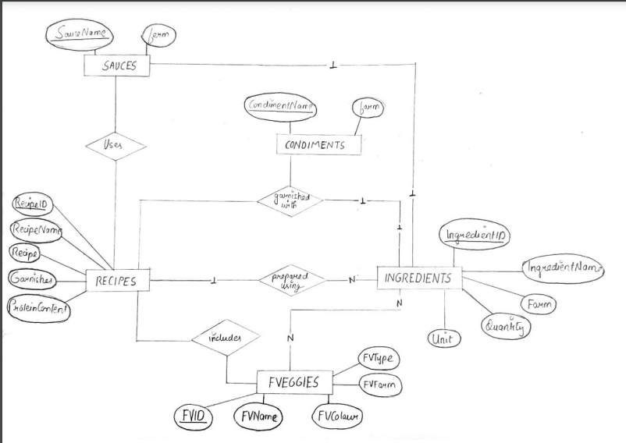

**ER Diagram using software**

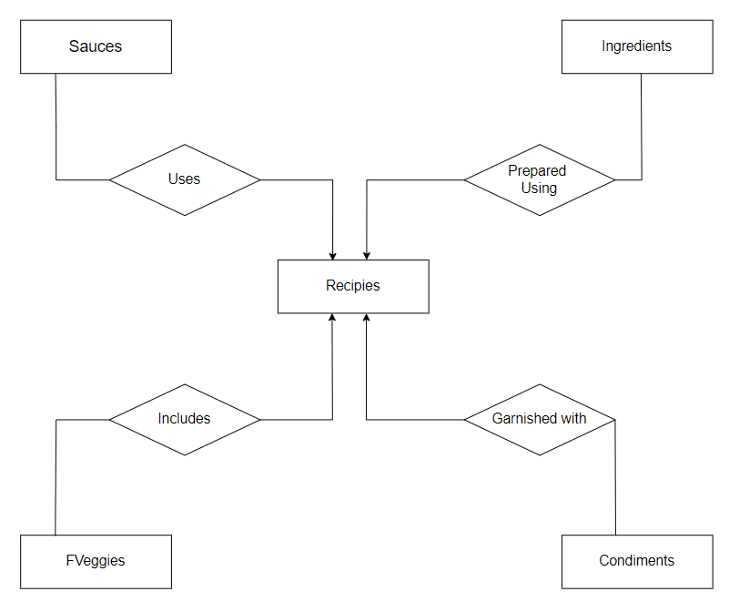

**Table Schema**

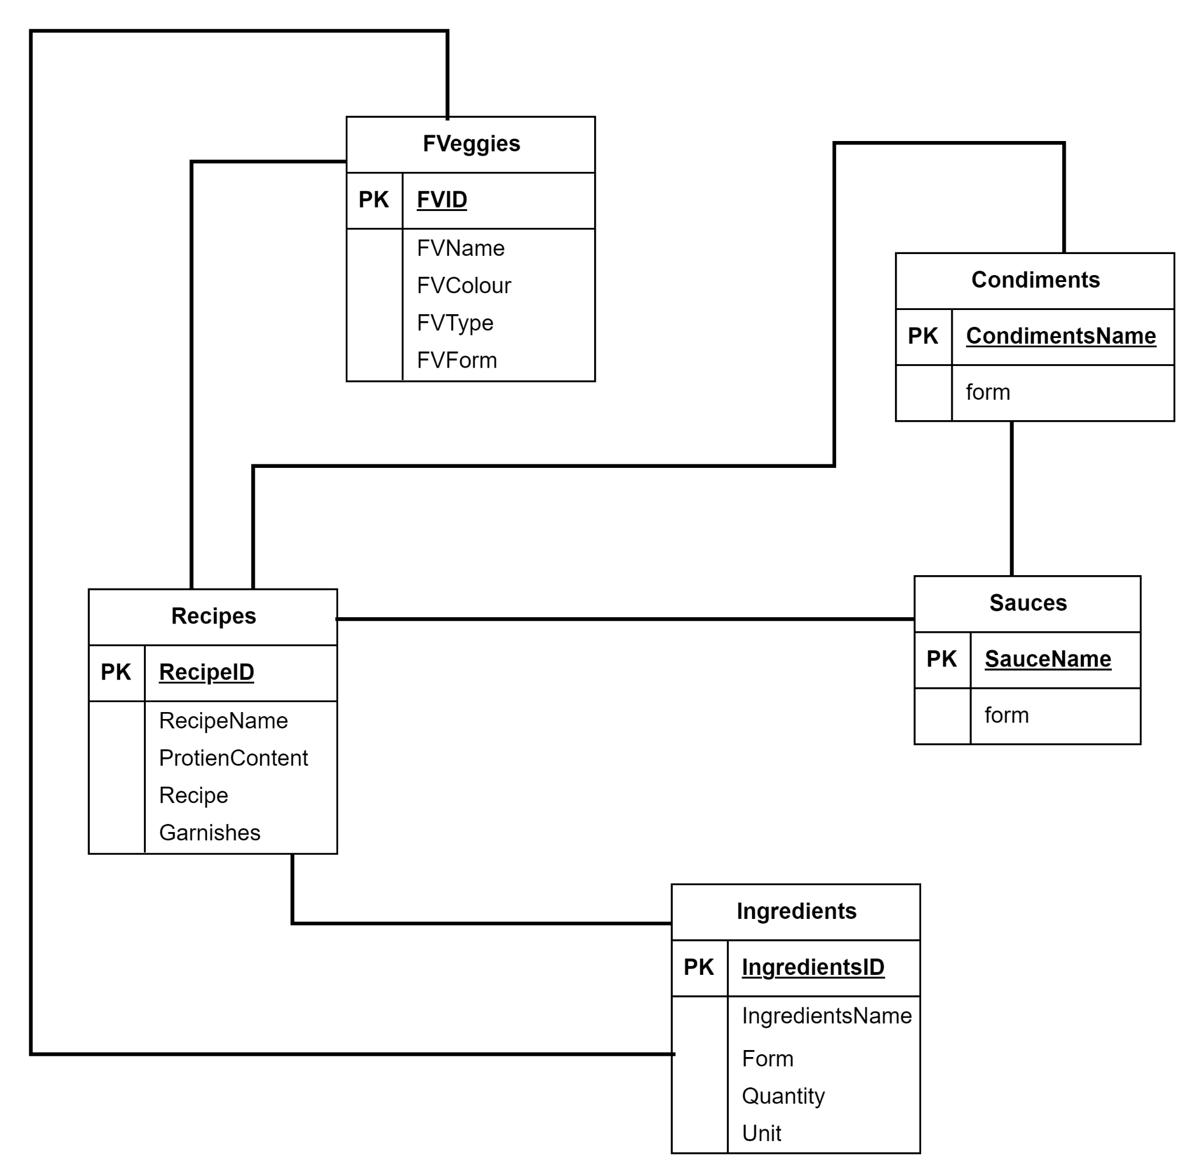

**Tables With Dummy Data**

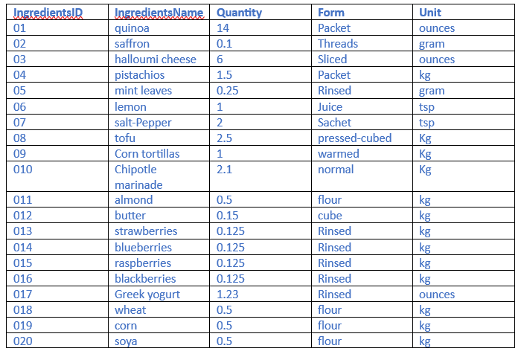

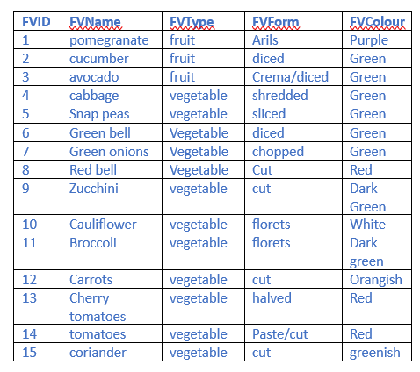

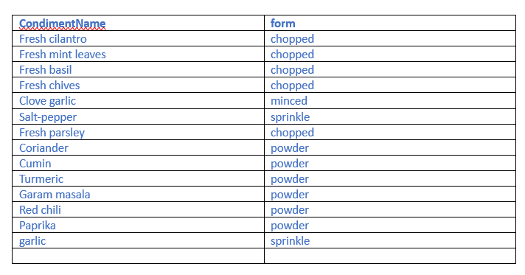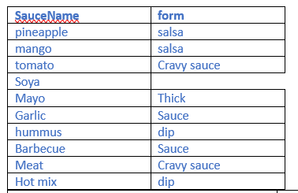

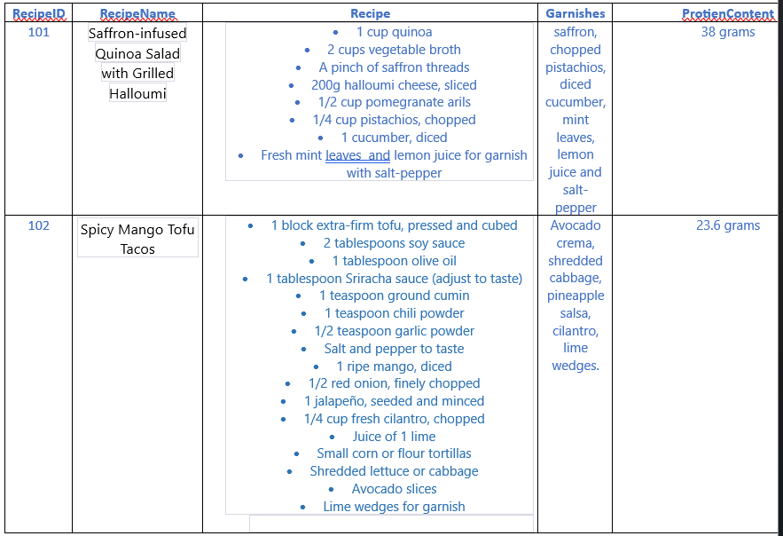

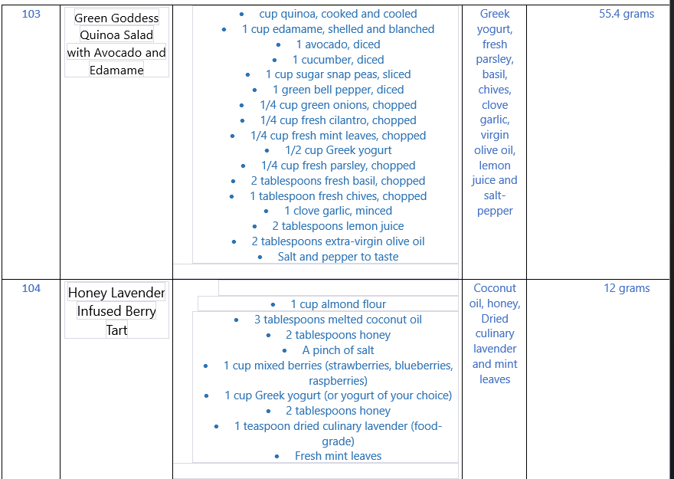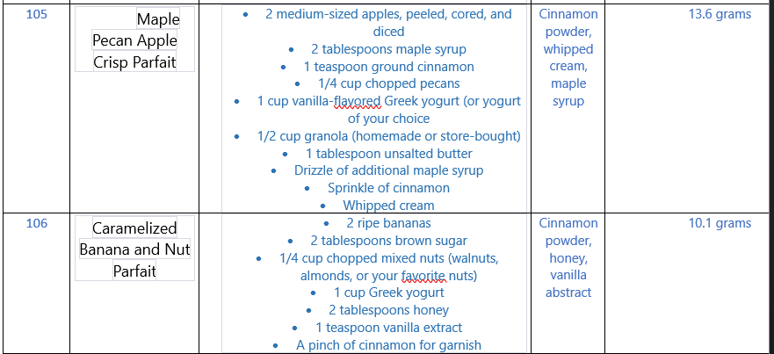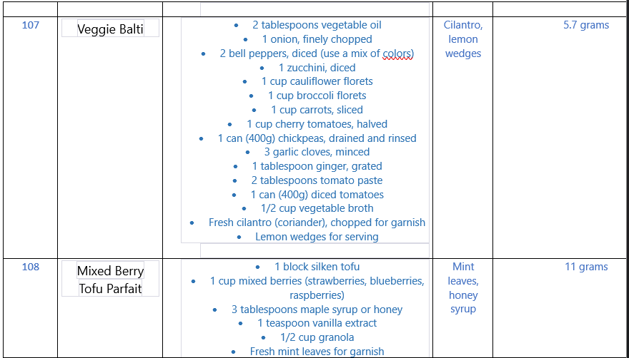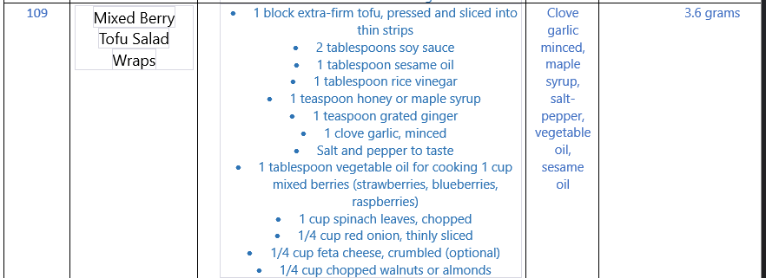

Table commands and Insert command:

**CONDIMENTS TABLE**

CREATE TABLE Condiments (

CondimentName VARCHAR(50)PRIMARY KEY,

form VARCHAR(50)

);

INSERT INTO Condiments (CondimentName, form) VALUES

('Fresh cilantro', 'chopped'),

('Fresh mint leaves', 'chopped'),

('Fresh basil', 'chopped'),

('Fresh chives', 'chopped'),

('Clove garlic', 'minced'),

('Salt-pepper', 'sprinkle'),

('Fresh parsley', 'chopped'),

('Coriander', 'powder'),

('Cumin', 'powder'),

('Turmeric', 'powder'),

('Garam masala', 'powder'),

('Red chili', 'powder'),

('Paprika', 'powder'),

('Garlic', 'sprinkle');

**SAUCES TABLE**

CREATE TABLE Sauces (

SauceName VARCHAR(50) PRIMARY KEY,

form VARCHAR(50)

);

INSERT INTO Sauces (SauceName, form) VALUES

('pineapple', 'salsa'),

('mango', 'salsa'),

('tomato', 'Cravy sauce'),

('Soya', 'dip'),

('Mayo', 'Thick'),

('Garlic', 'Sauce'),

('hummus', 'dip'),

('Barbecue', 'Sauce'),

('Meat', 'Cravy sauce'),

('Hot mix', 'dip');

**FVEGGIES TABLE**

CREATE TABLE FVeggies (

FVID INT PRIMARY KEY,

FVName VARCHAR(255),

FVType VARCHAR(50),

FVForm VARCHAR(50),

FVColour VARCHAR(50)

);

INSERT INTO FVeggies (FVID, FVName, FVType, FVForm, FVColour) VALUES

(1, 'pomegranate', 'fruit', 'Arils', 'Purple'),

(2, 'cucumber', 'fruit', 'diced', 'Green'),

(3, 'avocado', 'fruit', 'Crema/diced', 'Green'),

(4, 'cabbage', 'vegetable', 'shredded', 'Green'),

(5, 'Snap peas', 'vegetable', 'sliced', 'Green'),

(6, 'Green bell', 'Vegetable', 'diced', 'Green'),

(7, 'Green onions', 'Vegetable', 'chopped', 'Green'),

(8, 'Red bell', 'Vegetable', 'Cut', 'Red'),

(9, 'Zucchini', 'vegetable', 'cut', 'Dark Green'),

(10, 'Cauliflower', 'vegetable', 'florets', 'White'),

(11, 'Broccoli', 'vegetable', 'florets', 'Dark green'),

(12, 'Carrots', 'vegetable', 'cut', 'Orangish'),

(13, 'Cherry tomatoes', 'vegetable', 'halved', 'Red'),

(14, 'tomatoes', 'vegetable', 'Paste/cut', 'Red'),

(15, 'coriander', 'vegetable', 'cut', 'greenish');

**INGREDIENTS TABLE**

-- Create Ingredients table

CREATE TABLE Ingredients (

IngredientsID INT PRIMARY KEY,

IngredientsName VARCHAR(255),

Quantity DECIMAL(10, 3),

Form VARCHAR(50),

Unit VARCHAR(50)

);

INSERT INTO Ingredients (IngredientsID, IngredientsName, Quantity, Form, Unit)

VALUES

(01, 'quinoa', 14, 'Packet', 'ounces'),

(02, 'saffron', 0.1, 'Threads', 'gram'),

(03, 'halloumi cheese', 6, 'Sliced', 'ounces'),

(04, 'pistachios', 1.5, 'Packet', 'kg'),

(05, 'mint leaves', 0.25, 'Rinsed', 'gram'),

(06, 'lemon', 1, 'Juice', 'tsp'),

(07, 'salt-Pepper', 2, 'Sachet', 'tsp'),

(08, 'tofu', 2.5, 'pressed-cubed', 'kg'),

(09, 'Corn tortillas', 1, 'warmed', 'kg'),

(10, 'Chipotle marinade', 2.1, 'normal', 'kg'),

(11, 'almond', 0.5, 'flour', 'kg'),

(12, 'butter', 0.15, 'cube', 'kg'),

(13, 'strawberries', 0.125, 'Rinsed', 'kg'),

(14, 'blueberries', 0.125, 'Rinsed', 'kg'),

(15, 'raspberries', 0.125, 'Rinsed', 'kg'),

(16, 'blackberries', 0.125, 'Rinsed', 'kg'),

(17, 'Greek yogurt', 1.23, 'Rinsed', 'ounces'),

(18, 'wheat', 0.5, 'flour', 'kg'),

(19, 'corn', 0.5, 'flour', 'kg'),

(20, 'soya', 0.5, 'flour', 'kg');

**RECIPES TABLE**

-- Create Recipes table

CREATE TABLE Recipes (

RecipeID INT PRIMARY KEY,

RecipeName VARCHAR(255),

Garnishes TEXT,

Recipes TEXT,

ProteinContent FLOAT

);

INSERT INTO Recipes (RecipeID, RecipeName, Garnishes, Recipes, ProteinContent) VALUES

(101, 'Saffron-infused Quinoa Salad with Grilled Halloumi', 'saffron, chopped pistachios, diced cucumber, mint leaves, lemon juice and salt-pepper', '1 cup quinoa

2 cups vegetable broth

A pinch of saffron threads

200g halloumi cheese, sliced

1/2 cup pomegranate arils

1/4 cup pistachios, chopped

1 cucumber, diced

Fresh mint leaves and lemon juice for garnish with salt-pepper', 38),

(102, 'Spicy Mango Tofu Tacos', 'Avocado crema, shredded cabbage, pineapple salsa, cilantro, lime wedges.', '1 block extra-firm tofu, pressed and cubed

2 tablespoons soy sauce

1 tablespoon olive oil

1 tablespoon Sriracha sauce (adjust to taste)

1 teaspoon ground cumin

1 teaspoon chili powder

1/2 teaspoon garlic powder

Salt and pepper to taste

1 ripe mango, diced

1/2 red onion, finely chopped

1 jalapeño, seeded and minced

1/4 cup fresh cilantro, chopped

Juice of 1 lime

Small corn or flour tortillas

Shredded lettuce or cabbage

Avocado slices

Lime wedges for garnish', 23.6),

(103, 'Green Goddess Quinoa Salad with Avocado and Edamame', 'Greek yogurt, fresh parsley, basil, chives, clove garlic, virgin olive oil, lemon juice and salt-pepper', '1 cup quinoa, cooked and cooled

1 cup edamame, shelled and blanched

1 avocado, diced

1 cucumber, diced

1 cup sugar snap peas, sliced

1 green bell pepper, diced

1/4 cup green onions, chopped

1/4 cup fresh cilantro, chopped

1/4 cup fresh mint leaves, chopped

1/2 cup Greek yogurt

1/4 cup fresh parsley, chopped

2 tablespoons fresh basil, chopped

1 tablespoon fresh chives, chopped

1 clove garlic, minced

2 tablespoons lemon juice

2 tablespoons extra-virgin olive oil

Salt and pepper to taste', 55.4),

(104, 'Honey Lavender Infused Berry Tart', 'Coconut oil, honey, Dried culinary lavender and mint leaves', '1 cup almond flour

3 tablespoons melted coconut oil

2 tablespoons honey

A pinch of salt

1 cup mixed berries (strawberries, blueberries, raspberries)

1 cup Greek yogurt (or yogurt of your choice)

2 tablespoons honey

1 teaspoon dried culinary lavender (food-grade)

Fresh mint leaves', 12),

(105, 'Maple Pecan Apple Crisp Parfait', 'Cinnamon powder, whipped cream, maple syrup', '2 medium-sized apples, peeled, cored, and diced

2 tablespoons maple syrup

1 teaspoon ground cinnamon

1/4 cup chopped pecans

1 cup vanilla-flavored Greek yogurt (or yogurt of your choice)

1/2 cup granola (homemade or store-bought)

1 tablespoon unsalted butter

Drizzle of additional maple syrup

Sprinkle of cinnamon

Whipped cream', 13.6),

(106, 'Caramelized Banana and Nut Parfait', 'Cinnamon powder, honey, vanilla abstract', '2 ripe bananas

2 tablespoons brown sugar

1/4 cup chopped mixed nuts (walnuts, almonds, or your favorite nuts)

1 cup Greek yogurt

2 tablespoons honey

1 teaspoon vanilla extract

A pinch of cinnamon for garnish', 10.1),

(107, 'Veggie Balti', 'Cilantro, lemon wedges', '2 tablespoons vegetable oil

1 onion, finely chopped

2 bell peppers, diced (use a mix of colors)

1 zucchini, diced

1 cup cauliflower florets

1 cup broccoli florets

1 cup carrots, sliced

1 cup cherry tomatoes, halved

1 can (400g) chickpeas, drained and rinsed

3 garlic cloves, minced

1 tablespoon ginger, grated

2 tablespoons tomato paste

1 can (400g) diced tomatoes

1/2 cup vegetable broth

Fresh cilantro (coriander), chopped for garnish

Lemon wedges for serving', 5.7),

(108, 'Mixed Berry Tofu Parfait', 'Mint leaves, honey syrup', '1 block silken tofu

1 cup mixed berries (strawberries, blueberries, raspberries)

3 tablespoons maple syrup or honey

1 teaspoon vanilla extract

1/2 cup granola

Fresh mint leaves for garnish', 11),

(109, 'Mixed Berry Tofu Salad Wraps', 'Clove garlic minced, maple syrup, salt-pepper, vegetable oil, sesame oil', '1 block extra-firm tofu, pressed and sliced into thin strips

2 tablespoons soy sauce

1 tablespoon sesame oil

1 tablespoon rice vinegar

1 teaspoon honey or maple syrup

1 teaspoon grated ginger

1 clove garlic, minced

Salt and pepper to taste

1 tablespoon vegetable oil for cooking 1 cup mixed berries (strawberries, blueberries, raspberries)

1 cup spinach leaves, chopped

1/4 cup red onion, thinly sliced

1/4 cup feta cheese, crumbled (optional)

1/4 cup chopped walnuts or almonds', 3.6);

**Game details with sql queries and solutions**

PLAYER DETAILS :

You are Dhiren(Ren) born and brought up in Mumbai, India until you decided to pursue your Culinary Arts degree from London, UK . Your passion for food and making great inventory dishes becomes your main drive to uplift yourself and make the best out of your works using your skillset , to show it to the world. And the day finally arrives when you get an opportunity to prove yourself .

The great MasterChef Globe 2024 declares a contest worldwide.

Ren applies and gets in for the **audition round**.

Creating a signature dish involves combining unique flavours, textures, and presentations that reflect your culinary style.

In order to make his signature dish ‘spicy mango tofu tacos’ Ren is required to collect all the main ingredients before proceeding to make it.

QUESTION:

Choose the following items of ingredients with its form : tofu , Chipotle marinade, Corn tortillas.

ANSWER:

Select IngredientsName, Form

From Ingredients

Where IngredientsName in('tofu', 'Chipotle marinade', 'Corn tortillas');

QUESTION:

To finish off the preparation Ren requires salsa sauces for the topping.

ANSWER:

Select SauceName

From Sauces

Where form = 'salsa';

Well Well , the audition round dish gets a great applause from the judges and Ren gets qualified for the level based rounds.

**Ren enters Level 1**

Creating a dish by taste alone, without following a specific recipe, is often associated with a chef's intuition and culinary expertise.

Ren is called upon by the judges to taste a dish whose name and recipe is not declared. Ren upon tasting finds the following :

-some form of sliced cheese and a strong scent of olive oil, garnishes included saffron, chopped pistachios, diced cucumber, mint leaves, lemon juice and salt-pepper

QUESTION:.

Help Ren find the correct recipe through the provided garnishing info.

ANSWER:

Select Recipes

From Recipes

Where Garnishes = 'saffron, chopped pistachios, diced cucumber, mint leaves, lemon juice and salt-pepper';

QUESTION:

After knowing the recipe help Ren find the correct fruits to make it whose form is either arils or diced. (pomegranate and cucumber)

ANSWER:

Select FVName

From FVeggies

Where FVForm = 'Arils' or FVForm = 'diced' and FVType = 'fruit';

QUESTION:

Now Ren needs to gather all the required ingredients and its form. ( quinoa, halloumi cheese, saffron, pistachios, salt-pepper, lemon, mint leaves).

ANSWER:

Select IngredientsName, Form

From Ingredients

Where IngredientsName in('quinoa', 'halloumi cheese', 'saffron', 'pistachios', 'salt-pepper', 'lemon', 'mint leaves');

**Ren enters Level 2**

The challenge here gets all your arithmetic capabilities at test. As it turns out Ren has to make a dessert with criteria to have each ingredient weight not more than 1 kg and to ensure that the total of all ingredients do not exceed 3kg.

QUESTION:

So first help Ren count all the items from ingredients that weight less than 1kg.

ANSWER:

Select count(IngredientsName)

From Ingredients

Where Quantity < 1 and Unit = 'kg';

It is time to check whether Ren’s cart is exceeding 3kg limit or not.

QUESTION:

Ren needs to find a total of all his items so addition operation must be performed.

ANSWER:

Select sum(Quantity)

From Ingredients

Where Quantity < 1 and Unit = 'kg';

After getting a list of items available Ren decides to make a tart dish that can include all the given ingredients.

QUESTION:

Fetch Ren a perfect recipe that fits with the available ingredients. (Coconut oil, honey, Dried culinary lavender and mint leaves) with the garnishing info.

ANSWER:

Select RecipeName, Recipes

From Recipes

Where Garnishes = ('Coconut oil, honey, Dried culinary lavender and mint leaves');

**Ren enters Level 3**

Making a dish with a blend of ingredients that have a common colour is an art.

Ren is given colour green and he is supposed to make a dish with ingredients being green.

QUESTION:

Find all vegetables that are green .

ANSWER:

Select FVName

From FVeggies

Where ((FVType = 'vegetable' or FVType = 'Vegetable') and (FVColour = 'Green'));

QUESTION:

Now for seasoning purpose provide Ren with fruits, vegetables and condiments that are chopped. (join function)

ANSWER:

SELECT FVeggies.FVName, Condiments.CondimentName

From FVeggies

Join Condiments On Condiments.form = FVeggies.FVForm;

**Ren enters level 4**

To represent a dish that reflects on a countries culture and diverse culinary is quite a task.

Ren having completed his culinary degree from London decides to awe the judges by presenting the very fine speciality of London know by the name “veggie balti”. It is a very delicious vegetarian version of the popular balti curry, whose flavour and aroma spell binds one.

QUESTION:

In order to get the raw materials for curry making help Ren select all items that identify as a vegetable.

ANSWER:

Select FVName

From FVeggies

Where FVType = 'vegetable';

QUESTION:

Ren wants only powdered and sprinkled condiments for enhancing the flavour.

ANSWER:

Select CondimentName

From Condiments

Where form in ('powder' , 'sprinkle');

**Ren enters level 5**

Judges have decided to make this round a bit tricky.

The challenge will be to make a fine dish by use of only two ingredients such that 1st ingredient is least in weight while the second is the most.

QUESTION:

First rearrange the ingredients data from highest to lowest

ANSWER:

Select IngredientsName

From Ingredients

Order by Quantity desc;

QUESTION:

Help Ren fetch only the items from a limited list of ingredients such that 1 is least in weight while other the most and also ensure the unit is the same.

ANSWER:

Select *, max(Quantity)

From Ingredients

Where Unit = 'kg';

ANSWER:

Select *, min(Quantity)

From Ingredients

Where Unit = 'kg';

Ren is clearly lucky here because he might have a hand in winning this , the items that filters includes tofu and various berries. Now all he needs is a recipe that will have these two items as mains.

QUESTION:

Fetch all the recipes with Tofu and and Berry in its name.(make use of like function and ensure case-insensitive comparision)

ANSWER:

Select RecipeName

From Recipes

Where Lower(RecipeName) like '%tofu%' and lower(RecipeName) like '%berry%';

Ren has two recipes in hand and he goes for mixed berry tofu parfait. And vola! he has the judges awe-struct with his flavours.

**Ren finally enters the Gala round :**

And the wait finally pays off when the last round either decides his fate or success.

There will be different types of small challenges:

QUESTION:

First - find recipe that has at least one of the garnished item (lemon,garlic)

ANSWER:

Select RecipeName

From Recipes

Where lower(Garnishes) like '%lemon%' and lower(Garnishes) like '%garlic%';

QUESTION:

Second – find the recipe with highest protein content.

ANSWER:

Select RecipeName

From Recipes

Order by ProteinContent desc

Limit 1;

QUESTION:

Third – Retrieve all the recipes that include the word “onion” in its recipes.

ANSWER:

Select *

From Recipes

Where Recipes like '%onion%';

**Congratulations you have won the MasterChef Globe 2024 and are worthy of the prize that is the MasterChef Globe 2024 cup Award along with the winners apron.**